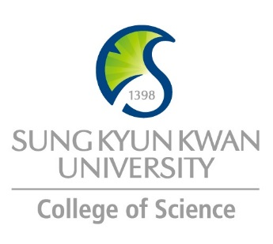 | Sungkyunkwan University (SKKU)  College of Science  Global Program Survey  2019 Spring – 2019 Fall | University/School  Logo

Institution | Linnaeus University
Country | Sweden |  | City |  | Växjö and Kalmar
Webpage/ Social Media | www.lnu.se
Postal Address | Universitetsplatsen 1, S-35195 Växjö, Sweden
Contact  Information |  | Primary |  | Secondary
 | Name | Maria ERIKSSON |  | Elena VINCI-HYTTER
 | Position | Section Manager, International Office |  | Facutly of Technology
 | Function
 | Email | Maria.Eriksson@lnu.se |  | Elena.Vinci-Hytter@lnu.se
 | Phone | +46 470 70 82 48 |  | +46 470 70 88 03

Program | Exchange studies
Period | Academic year 2018/2019
Number of Exchange Places Offered | 1 semester exchange |  | 2 semesters exchange |  | Others
 | 4 |  | 2 |  | Please specify
Applicable Major | Biological Sciences | Mathematics |  | Physics |  | Chemistry
 | x | x |  | x |  | x
Applicable Degree | Undergraduate |  | Master |  | PhD
 | x |  | x
Fees | Tuition Fee |  | Other Fees
Academic Year | 2018/2019
Academic Calendar | September 3 - January 2019 = fall semester / January 21, 2019 – June 3, 2019
Credit System | 30 Swedish credits per semester (hp), equivalent to 30 ECTS

Application Procedure | https://lnu.se/en/education/exchange-studies/
Application Guide | https://lnu.se/en/education/exchange-studies/
Requirements | Language | English Proficiency
 | Academic | Depending on course, see prerequisites for each course
 | Others
Required Documents | Online application, Copy of passport, Transcript of records, Language Proficiency Report
Application Deadline | October 15 for spring semester and April 15 for fall semester
Nomination Deadline | October 1 for spring semester and April 1 for fall semester

Primary Language of Instruction | English | Secondary Language of Instruction, if any
Course Catalogue | https://lnu.se/en/education/exchange-studies/courses-and-programmes-for-exchange-students/
Courses Taught in English | https://lnu.se/en/education/exchange-studies/courses-and-programmes-for-exchange-students/

Accommodation | https://lnu.se/en/education/exchange-studies/courses-and-programmes-for-exchange-students/
Estimated Cost of Living | https://lnu.se/en/education/exchange-studies/courses-and-programmes-for-exchange-students/
Financial Aids | N/A
Special Programs/Offers | N/A
Expected Arrival Date | https://lnu.se/en/education/Before-your-studies/preparing-for-your-stay/
Number of Exchange Students per semester |  | Diversity Exchange Students (Demographics)
Useful Links

Note

