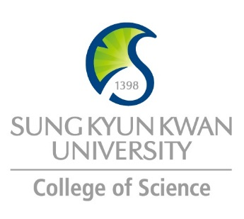 | Sungkyunkwan University (SKKU)  College of Science  Global Program Survey  2018 Spring

Institution | Tohoku University
Country | Japan |  | City |  | Sendai
Webpage/ Social Media | http://www.tohoku.ac.jp/en/
Postal Address | 41 Kawauchi, Aoba-ku, Sendai 980-8576, JAPAN
Contact  Information |  | Primary |  | Secondary
 | Name | Shuichi Tsukamoto (Mr.) |  | Kango Koyama (Mr.)
 | Position | Chief for incoming students |  | Chief for outgoing students
 | Function | Coordinator for Student Exchange Program |  | Coordinator for Student Exchange Program
 | Email | studyab@grp.tohoku.ac.jp |  | sab_query@grp.tohoku.ac.jp
 | Phone | +81-22-795-3775 |  | +81-22-795-7820

Program | JYPE/COLABS/DEEP
Period | AY 2017-2018
Number of Exchange Places Offered | 1 semester exchange |  | 2 semesters exchange |  | Others
 | Up to 1 |  | Up to 1
Applicable Major | Biological Sciences | Mathematics |  | Physics |  | Chemistry
 | Yes | Yes |  | Yes |  | Yes
Applicable Degree | Undergraduate |  | Master |  | PhD
 | JYPE  DEEP |  | COLABS  DEEP |  | COLABS  DEEP
Fees | Tuition Fee |  | Other Fees
 | Waived |  | Dormitory, Insurance, Meals, Transportation, Books
Academic Year | October 1 – September 30
Academic Calendar | 2018 Fall: October 1 to March 31  2019 Spring: April 1 to September 30
Credit System | 1 credit is awarded for 45 hours of course work

Application Procedure | Online application, form must be filled by partner universities coordinator (not students)
Application Guide | Fall Semester: January 10 – February 20  Spring Semester: October 1 – November 15
Requirements | Language | English
 | Academic
 | Others
Required Documents | Please see attached fact sheet
Application Deadline | Fall Semester: February 20  Spring Semester: November 15
Nomination Deadline

Primary Language of Instruction | English, except undergraduate DEEP | Secondary Language of Instruction, if any | Japanese
Course Catalogue | http://www.tohoku.ac.jp/en/academics/exchange_programs.html
Courses Taught in English | JYPE, IPLA, COLABS

Accommodation | Available  http://sup.bureau.tohoku.ac.jp/housing/kaikan_en.html  http://sup.bureau.tohoku.ac.jp/housing/uh_en.html
Estimated Cost of Living | 80,000 – 100,000 JPY/month
Financial Aids | JASSO Scholarship (80,000JPY) is available for student with more than 2.3/3.0 GPA
Special Programs/Offers
Expected Arrival Date | September 25, 2018
Number of Exchange Students per semester | Up to 1 | Diversity Exchange Students (Demographics) | Top 10 of Fall 2015 semester Enrollment  (total number: 187)  China 20.3%  Germany 12.8%  USA 12.8%  Taiwan 9.1%  Sweden 5.9%  Thailand 5.3%  Finland 4.8%  France 4.3%  Indonesia 4.3%  Russia 2.7%  We receive 3students from Korea.
Useful Links | http://www.insc.tohoku.ac.jp/english/exchange/  http://www.tohoku.ac.jp/en/academics/exchange_programs.html  http://sup.bureau.tohoku.ac.jp/index_en.html  http://sup.bureau.tohoku.ac.jp/news/img/PocketGuide.pdf

Note

