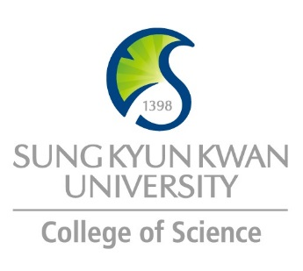 | Sungkyunkwan University (SKKU)  College of Science  Global Program Survey  2018 - 2019

Institution | VNU University of Science
Country | Vietnam |  | City |  | Hanoi
Webpage/ Social Media | hus.vnu.edu.vn
Postal Address | hus.vnu.edu.vn/en
Contact  Information |  | Primary |  | Secondary
 | Name | Nguyen Minh Hai |  | Le Thanh Hanh
 | Position | Head of IR Office |  | IR Office
 | Function | International Cooperation |  | International Relation
 | Email | minhhai.nguyen@hus.edu.vn |  | hai.cclab@gmail.com
 | Phone | +84-243-5587677 |  | +84-243-8584615

Program | Advanced and International Standard Programs
Period | Do not exceed 12 months
Number of Exchange Places Offered | 1 semester exchange |  | 2 semesters exchange |  | Others
 | √ |  | √ |  | Research exchange
Applicable Major | Biological Sciences | Mathematics |  | Physics |  | Chemistry
 | √ | √ |  | √ |  | √
Applicable Degree | Undergraduate |  | Master |  | PhD
 | √
Fees | Tuition Fee |  | Other Fees
 | Waived |  | Accommodation, Travel, Daily expense, Flight ticket, Insurance…
Academic Year | 2018 - 2019
Academic Calendar | Fall semester: 9/2018 - 12/2018  Spring semester: 02/2019 – 5/2019
Credit System

Application Procedure | The application should be sent directly to: International Relations Office (admission@hus.edu.vn)
Application Guide | For further questions regarding our entry requirements, please contact the faculty to which you are applying via: http://hus.vnu.edu.vn/en/node/52506 , or at: admission@hus.edu.vn
Requirements | Language | English
 | Academic | At least two semesters at home university and proficient in English.
 | Others | The duration of exchange must not exceed 12 months
Required Documents | Application form (Form 1) ;  - List of courses to be taken (Form 2) ;  - Official transcript;  - Letter of recommendation from home university;  - Language proficiency certificate (exempted if you are English-speaking);  - Health certificate;  - Statement of financial proof;  - Four recently taken photos;  - Photocopy of passport;  - Letter of recommendation from a scientist (for post graduate students).
Application Deadline | Fall semester: July, 2018  Spring semester: November, 2018
Nomination Deadline | Fall semester: June, 2018  Spring semester: October, 2018

Primary Language of Instruction | Vietnamese | Secondary Language of Instruction, if any | English
Course Catalogue | Listed at : http://hus.vnu.edu.vn/en/node/57280
Courses Taught in English | - Advanced Program in Chemistry  - Advanced Program in Environmental Science  - International Standard Program in Physics  - International Standard Program in Biology  - International Standard Program in Geology

Accommodation | VNU Dormitory
Estimated Cost of Living | 300 USD/month
Financial Aids | None
Special Programs/Offers
Expected Arrival Date
Number of Exchange Students per semester | Up to four (04) students | Diversity Exchange Students (Demographics)
Useful Links | hus.vnu.edu.vn/en  http://hus.vnu.edu.vn/en/node/52506 (Faculties list)  http://hus.vnu.edu.vn/en/node/57280 (Exchange information)  css.vnu.edu.vn (VNU student services; Dormitory)

Note

