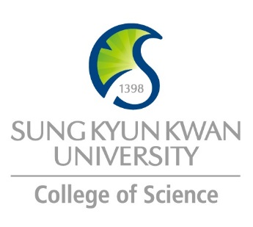 | Sungkyunkwan University (SKKU)  College of Science  Global Program Survey  2018 Fall – 2019 Spring

Institution | Mae Fah Luang University
Country | Thailand |  | City |  | Chiang Rai
Webpage/ Social Media | http://www.mfu.ac.th/eng/
Postal Address | International Affairs Division, Mae Fah Luang University, 333 Moo 1, Thasud, Muang,  Chiang Rai, Thailand 57100
Contact  Information |  | Primary |  | Secondary
 | Name | Ms. Warunee Kaewbunruang
 | Position | Administrative Officer
 | Function | Student Exchange Program Coordinator
 | Email | warunee.kae@mfu.ac.th
 | Phone | +66 (0) 5391 6090

Program | Student Exchange Programme
Period | 1 semester or 1 academic year (2 semesters)
Number of Exchange Places Offered | 1 semester exchange |  | 2 semesters exchange |  | Others
 | 2 |  | 2 |  | We would not have any problem to accept these students because of the policy of Mae Fah Luang University, we would appreciate to welcome all exchange students.
Applicable Major | Biological Sciences | Mathematics |  | Physics |  | Chemistry
 | - | - |  | - |  | -
We offered 79 programme at Mae Fah Luang University.
For more information, please visit our website at http://www.mfu.ac.th/eng/at-english.php.

Note: At Mae Fah Luang University, English is being used a medium of instruction in all school except School of Nursing and School Law. This is because both degrees require a qualification examination in Thai by the central body.
Applicable Degree | Undergraduate |  | Master |  | PhD
Fees | Tuition Fee |  | Other Fees
 | Waive |  | https://goo.gl/cDm61y
Academic Year | 2018-2019
Academic Calendar | Semester I (August – December 2018) Semester II (January-May 2019)
Credit System | UMAP Credit Transfer System (UCTS)

Application Procedure | https://goo.gl/tm8QRs
Application Guide | https://goo.gl/tm8QRs
Requirements | Language | English
 | Academic | There are no minimum requirements for GPA. We trust our partner universities would select students that are suitably qualified to participate in the Student Exchange Programme at Mae Fah Luang University.
 | Others | -
Required Documents | • Copy of passport  • Academic transcript in English  • Confirmation of student status from home university  • English proficiency score report: TOEFL, IELTS, TOEIC (if any)  • A Recommendation Letter from student’s Academic Advisor supporting the application  • A Statement of Purpose defining student’s academic career and personal motivations for  Student exchange programme at MFU (approximately 300 words)
Application Deadline | Semester I : 30 June every year  Semester II : 30 November every year
Nomination Deadline | Semester I : 30 June every year  Semester II : 30 November every year

Primary Language of Instruction | English | Secondary Language of Instruction, if any | -
Course Catalogue | https://reg.mfu.ac.th/registrar/class_info.asp?avs127702058=3
Courses Taught in English | The Majority of courses are offered in English.

Accommodation | https://goo.gl/WVpc53
Estimated Cost of Living | https://goo.gl/cDm61y
Financial Aids | -
Special Programs/Offers | -
Expected Arrival Date | 3 days before the start of semester.
Number of Exchange Students per semester | 30 exchange students per semester | Diversity Exchange Students (Demographics) | American, Austrian, Bruneian, Czech, Filipinos, Finish, French, German, Hungarian, Indonesian, Japanese, Korean, Malaysian, Taiwanese and Vietnamese
Useful Links | http://web2.mfu.ac.th/division/inter/?page_id=51

Note

