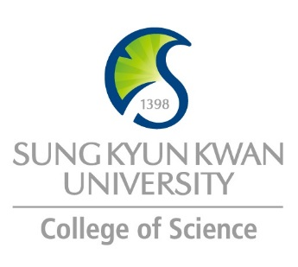 | Sungkyunkwan University (SKKU)  College of Science  Global Program Survey  2018 Fall

Institution | Umeå University, Department of Chemistry
Country | Sweden |  | City |  | Umeå
Webpage/ Social Media | http://www.umu.se/english/?languageId=1
Postal Address | Department of chemistry, 901 88 Umeå
Contact  Information |  | Primary |  | Secondary
 | Name | Solomon Tesfalidet |  | Maria Jansson
 | Position | Associate professor |  | Student administrator
 | Function | International coordinator
 | Email | Solomon.tesfalidet@chem.umu.se |  | Maria.jansson@chem.umu.se
 | Phone | +46(0)90 7867052 |  | +46(0)90 786 52 62

Program | Chemistry
Period | Spring and autumn semester 2018
Number of Exchange Places Offered | 1 semester exchange |  | 2 semesters exchange |  | Others
 | 2 |  | 2
Applicable Major | Biological Sciences | Mathematics |  | Physics |  | Chemistry
 |  |  |  |  |  | x
Applicable Degree | Undergraduate |  | Master |  | PhD
 | x |  | x
Fees | Tuition Fee |  | Other Fees
Academic Year | 2018-2019
Academic Calendar | 3/9 2018 – 9/6 2019, Fall semester 2018 is September 3 to January 20..
Credit System | ECTS

Application Procedure | See information sent separately:
Application Guide | www.student.umu.se/english/during-your-studies/your-continued-studies/courselist
Requirements | Language | English
 | Academic | See separate information package
 | Others
Required Documents | See information package sent from international admission office
Application Deadline | 15 April
Nomination Deadline | 1 April

Primary Language of Instruction | English | Secondary Language of Instruction, if any
Course Catalogue | http://www.umu.se/english/education/courses-and-programmes
Courses Taught in English | All courses at the department of chemistry are taught in English

Accommodation | 2800 SEK/month
Estimated Cost of Living | 7500 SEK/month including accommodation
Financial Aids
Special Programs/Offers
Expected Arrival Date | 1-2 September, The fall semester 2018 starts September 3.
Number of Exchange Students per semester |  | Diversity Exchange Students (Demographics)
Useful Links | http://www.chemistry.umu.se/english/?languageId=1  See information package sent from international admission office

Note

