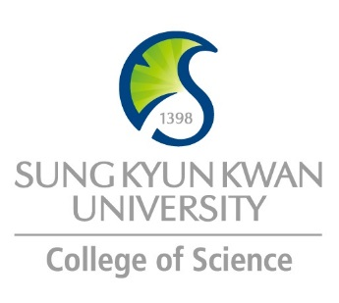 | Sungkyunkwan University (SKKU)  College of Science  Global Program Survey  2017 Spring | 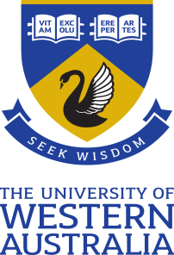

Institution | The University of Western Australia
Country | Australia |  | City |  | Perth
Webpage/ Social Media | www.uwa.edu.au
Postal Address | Global Learning Office M352, 35 Stirling Highway, Crawley WA 6009
Contact  Information |  | Primary |  | Secondary
 | Name | Fiona Maley |  | Broderick Moncrieff
 | Position | Study Abroad Adviser |  | Study Abroad Adviser
 | Function | SKKU to UWA Adviser |  | UWA to SKKU Adviser
 | Email | fiona.maley@uwa.edu.au |  | broderick.moncrieff@uwa.edu.au
 | Phone | +61 8 6488 2298 |  | +61 8 6488 3536

Program | University-Wide Exchange Program / Study Abroad Program
Period | 2018/2019
Number of Exchange Places Offered | 1 semester exchange |  | 2 semesters exchange |  | Others
 | 2 |  | 1 |  | 1 semester place for 2017 spring
Applicable Major | Biological Sciences | Mathematics |  | Physics |  | Chemistry
 | Yes | Yes |  | Yes |  | Yes
Applicable Degree | Undergraduate |  | Master |  | PhD
 | Yes |  | Yes
Fees | Tuition Fee |  | Other Fees
 | AU$13,700 for Study Abroad /  $0 for Exchange students |  | Overseas Student Health Cover: 6 months AU$330  Student Services and Amenities Fee:  Study Abroad Student AU$149 per semester  Exchange Students - waived
Academic Year | 2018
Academic Calendar | Semester 1, 2018: 26/02/2018 – 30/06/2018  Semester 2, 2018: 30/07/2018 – 30/12/2018  For a full list of important dates in 2018 please go to: http://www.student.uwa.edu.au/course/dates/important.
Credit System | 24 points per semester. Most units are worth 6 credit points each, therefore students will enrol in 4 units per semester.

Application Procedure | Nominations to Fiona Maley via nomination template. Students will then be emailed login details to complete an online application.
Application Guide | For information on how to apply please go to: https://study.uwa.edu.au/global or directly to https://study.uwa.edu.au/courses-and-careers/study-abroad-and-student-exchange/Completing-exchange-at-UWA
Requirements | Language | For a full list of acceptable tests please go to: https://study.uwa.edu.au/how-to-apply/entry-requirements/english-language-requirements
 | Academic | UG: Completion of one semester of tertiary study and be nominated by SKKU.  PG: Completion of a Bachelor’s Degree.
 | Others | If students don’t meet the standard English Language requirements, the may be able to gain admission through the Alternative English Language pathway. Students must enrol in at least one of the following units in their first semester of study at UWA: HUMA1901 or HUMA1902. Required scores are:  IELTS: Overall score of 6.0 with no band less than 5.5.  TOEFL: Overall score of 70 with min 20 in W; 14 in R; 19 in S; and 17 in L.
Required Documents | - Academic Transcript  - English Language Competency Test  - Proposed Study List  - Stamped and Signed copy of passport  - Printed and signed application  All documents to be uploaded to the OASYS system. Hard copies are not required.
Application Deadline | 1 December 2016
Nomination Deadline | 15 November 2016

Primary Language of Instruction | English | Secondary Language of Instruction, if any
Course Catalogue | http://handbooks.uwa.edu.au Please note, courses are referred to as Units at UWA.  http://handbooks.uwa.edu.au/units?section=faclist gives list of units by discipline/faculty
Courses Taught in English

Accommodation | For information on on-campus and off-campus accommodation please go to: https://study.uwa.edu.au/student-life/accommodation
Estimated Cost of Living | Students are expected to budget for between $370 and $500 per week. For a break down of estimated costs please go to: https://study.uwa.edu.au/international-students/life-in-perth/cost-of-living
Financial Aids
Special Programs/Offers
Expected Arrival Date | Orientation commences 19 February 2018
Number of Exchange Students per semester | 4 students for the whole SKKU exchange agreement | Diversity Exchange Students (Demographics)
Useful Links | For Incoming Exchange/Study Abroad students: https://study.uwa.edu.au/global

Note

